Development of a Java-based Online School Enrollment System

A System Presented to:
Mr. John Elsir Cuarentas Trainer

Experts Technology Assessment and Training Center Inc.

Caloocan City
In Partial Fulfillment of the Requirements for the
Course Programming (Java) NC III

Submitted By:
Cruz, Jerwin E.
Layos, Joland
Lazaro, Nathalie Jane D.
Matiga, John Michael B.
Villabroza, Clark Darren J.

July 14, 2026

Table of Contents
1.0 Introduction 3
2.0 Objectives 4
2.1 General Objectives 4
2.2 Specialized Objectives 4
3.0 Scope and Delimitation 5
3.1 Scope 5
3.2 Delimitation 5
4.0 Significance of the Study 6
5.0 Program Output 7
6.0 Conclusion 9
7.0 Recommendation 9
References 11

1.0 Introduction
The integration of digital technology and education has become one of the significant trends in educational reform worldwide. Educational institutions, mainly the registrar's office workflow, rely heavily on accurate and efficient administrative processes to manage students’ academic journeys. According to Anderson (2004), the core registrar roles centre on bringing in and registering each student class; providing the systems, records, and clerical support to schedule classes and exams, and documenting students' academic progress and tuition settlement. In today’s setting, traditional, manual or loosely structured digital systems often introduce inefficiencies such as redundant data entry, disorganized interfaces and data, and lack of safeguards against accidental data loss. These issues become more pronounced as the number of students, courses, and financial transactions grows, making it difficult for administrative staff to track records accurately. This paper presents the design and development of a Java-based Online School Enrollment System, built using Model-View-Controller (MVC) architecture in conjunction with the Data Access Object (DAO) design pattern, JDBC, and a MySQL database, to address these administrative and data-management challenges.

The System is composed of four core modules that mirror the essential functions of the school enrollment process: Student Registration, Course Management, Enrollment and Tuition Payment, and the Dashboard that contains the overview of the total activities. To maintain consistency across the database, student records follow a standardized format, while course records automatically compute total tuition based on the unit count and tuition rate per unit, minimizing the risk of manual computation errors. However, these modules were not designed as isolated, disconnected sets of create-read-update-delete operations. Instead, each was shaped around how administrative staff actually interact with student and course records on a daily basis, resulting in an iterative design process aimed at reducing interface clutter, eliminating repetitive actions, and presenting information in a manner that supports the way administrative decisions are typically made in a real school setting.

A significant portion of the system's development focused on improving the user experience across all modules, guided by an iterative design process that consolidated secondary actions into contextual views, replaced one-at-a-time course selection with multi-select enrollment and combined success dialogs, and organized tuition payment by student with support for multiple payment methods and audit logging. Rather than presenting every possible action at once, each module prioritizes the primary input process first, with secondary actions such as viewing, editing, and discarding records made accessible only when relevant, ensuring that the administrative staff's attention remains on the task at hand. This design philosophy keeps the registrar's workflow streamlined and consistent across modules, aligning the interface with the natural flow of administrative tasks in a way that reduces friction and minimizes the likelihood of human error during critical enrollment and payment transactions.

Overall, the development of the proposed Java-based Online School Enrollment System demonstrates how the application of established software engineering principles and user-centered interface design can address common administrative challenges in school enrollment. By integrating MVC architecture, the DAO design pattern, JDBC, and a MySQL database, the system provides a structured, maintainable, and efficient solution that supports registrar operations while reducing manual errors and improving workflow efficiency. The succeeding sections of this paper discuss the system's design, developement, and evaluation, highlighting how its architecture and interface decisions contribute to a more streamlined, reliable, and user-friendly enrollment process for educational institutions.

2.0 Objectives

2.1 General Objectives
To design and develop a Java-based Online School Enrollment System that streamlines student registration, course management, enrollment, and tuition payment processes through a structured, database-driven application built on MVC architecture and DAO design pattern.

2.2 Specialized Objectives
To design and develop a Java-based Online School Enrollment System that streamlines student registration, course management, enrollment, and tuition payment process, the developers intend to seek the following specialized objectives:
- Develop a Student Registration module that enables the creation, updating, viewing, and management of standardized student records stored in a MySQL database.
- Design a Course Management module that allows administrators to manage course information and automatically compute tuition fees based on the number of units and tuition rate per unit.
- Develop an Enrollment and Tuition Payment module that supports multi-course enrollment, records student payment transactions using different payment methods, and maintains an audit log for transaction monitoring.
- Design an interactive Dashboard module that provides administrators with an overview of enrollment activities, student records, course information, and payment summaries to support administrative decision-making.

3.0 Scope and Delimitation
According to Simon and Goes (2013), the scope of the study refers to the parameters under which the study will be operating. While Delimitations of the study are those characteristics that arise from limitations in the scope of the study (defining the boundaries) and by the conscious exclusionary and inclusionary decisions made during the development of the study plan.

The scope and delimitations of this study establish the boundaries of the proposed Java-based Online School Enrollment System by defining its intended coverage, functionalities, and features, as well as the aspects intentionally excluded from its development. These boundaries provide a clear understanding of the system's purpose, ensuring that the study remains focused on achieving its objectives while identifying the extent of its design and application.

3.1 Scope
This study focuses on the design and development of a Java-based online school enrollment system that uses a centralized, database-driven application to improve registrar operations and expedite the enrollment process. The Model-View-Controller (MVC) architectural pattern and the Data Access Object (DAO) design pattern are followed in the development of the system using Java and Java Swing for the graphical user interface. For dependable data storage and retrieval, JDBC is used to create communication between the application and a MySQL database.

The four main components of the suggested system are the Dashboard, Enrollment and Tuition Payment, Course Management, and Student Registration. While the Course Management module allows administrative staffs to create, update, and organize course information with automatic tuition fee computation based on the number of units and tuition rate per unit, the Student Registration module maintains standardized student records. Administrators can process tuition payments using different payment methods, enroll students in multiple courses, and keep transaction records with audit logging using the Enrollment and Tuition Payment module. In the meantime, the Dashboard helps administrators keep an eye on registrar operations by summarizing student, course, enrollment, and payment activities. The system also incorporates user-centered interface improvements designed to simplify administrative workflows, minimize repetitive tasks, and reduce the likelihood of manual errors during enrollment and payment transactions.

3.2 Delimitation
The study is purposefully restricted to the creation of a desktop-based enrollment management program for use by administrative staff or registrars. The core enrollment process, which includes student registration, course management, enrollment, tuition payment, and dashboard monitoring, is supported by the system. It does not offer distinct user accounts or self-service portals for parents, teachers, students, or other stakeholders.

Additionally, the system is designed to function in a local network or standalone environment and is built using a local MySQL database connected via JDBC. This study does not cover features like online enrollment, cloud deployment, mobile accessibility, integration with external payment gateways or banking services, SMS or email notifications, and synchronization with other institutional information systems. Similarly, in order to keep the study's focus on enhancing the effectiveness of the enrollment and tuition payment procedures, academic functions like class scheduling, grade management, attendance monitoring, faculty workload management, and learning management system (LMS) integration are purposefully left out.

4.0 Significance of the Study

This study is beneficial to the following:

Registrar and Administrative Staff: The system directly supports the registrar's office by automating student registration, tuition computation, and record management, tasks that are otherwise vulnerable to redundant data entry and manual computation mistakes. Computerization of administrative processes has consistently been associated with fewer human errors and faster transaction processing (Anderson, 2004). Because the system separates data-handling logic from the presentation layer through the Model-View-Controller (MVC) architecture and Data Access Object (DAO) pattern, staff also benefit from a platform that is easier to maintain and troubleshoot over time (Necula, 2024).

Students: Enrollees experience a faster, more organized registration and tuition payment process, with less time spent on repetitive paperwork and long queues. Comparable online enrollment systems adopted by other schools have been reported to successfully minimize errors, shorten waiting times, and improve the overall enrollment experience of students (Aspa et al., 2025).

Professors or Teachers: The Course Management module gives professors or teachers a consolidated, up-to-date view of class rosters, unit loads, and enrollment status, reducing the coordination workload that traditionally falls on instructors and registrar staff working from disconnected records.

Future Researchers and Developers: The design decisions documented in this study, particularly the use of MVC architecture together with the DAO pattern, JDBC, and MySQL, may serve as a reference for future capstone or thesis projects that explore Java-based school management systems, giving succeeding researchers a starting point for further enhancement (Necula, 2024).

5.0 Program Output

5.1 System Modules
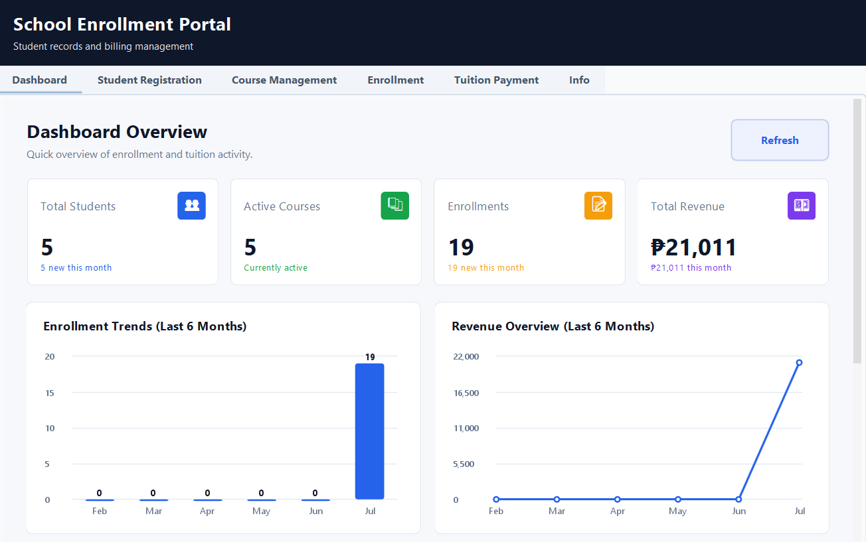
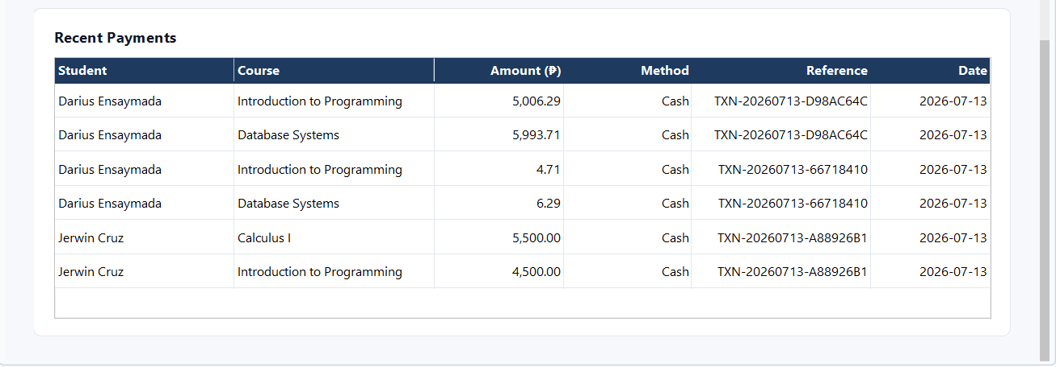
Figure 5.1.1. Dashboard Overview

The Dashboard Overview presents a quick overview of Enrollment and Tuition activity. It shows the total student, active courses, enrollments, and total revenue of the Educational Institution.

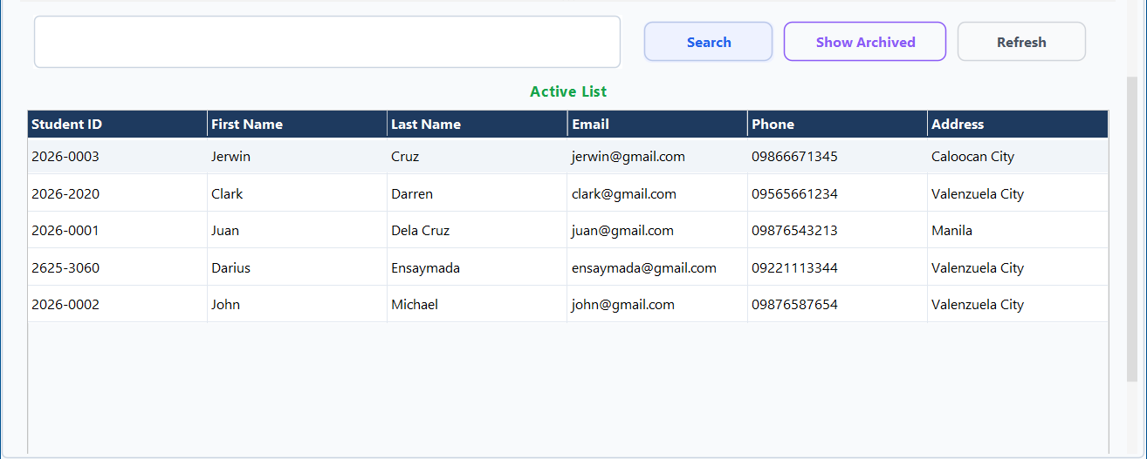
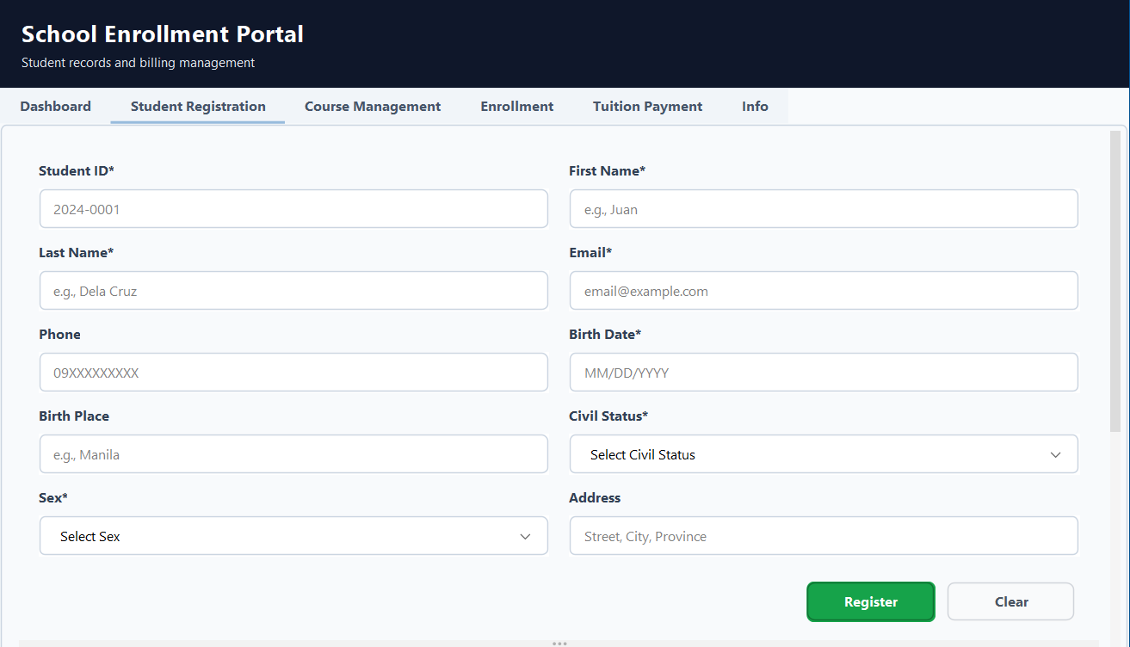
Figure 5.1.2. Student Registration

The Student Registration is designed to simplify the process of registering and managing student records within the School Enrollment Portal. It provides comprehensive generic format and dashboard list that displays active students in the collection.

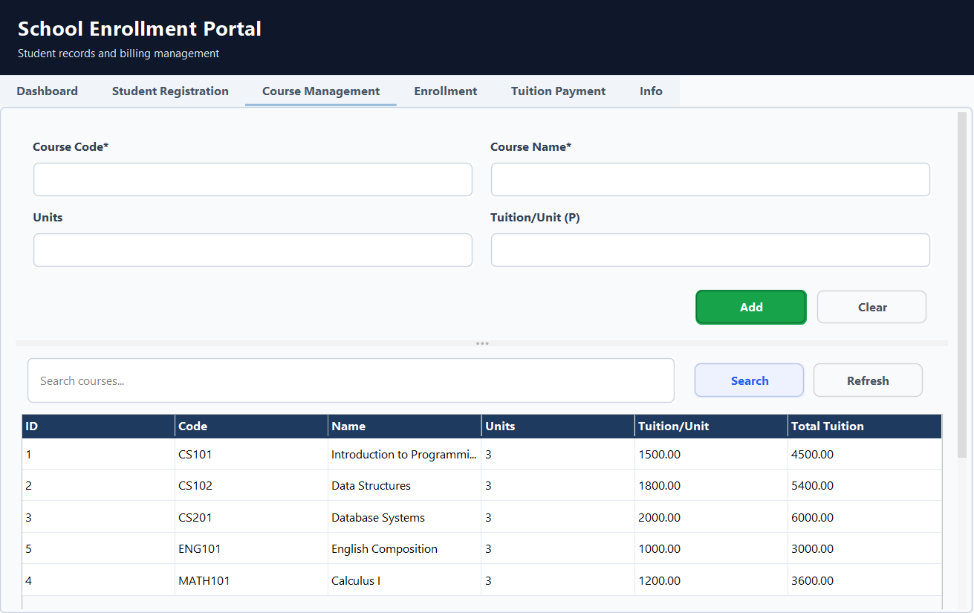
Figure 5.1.3. Course Management

The Course Management dashboard allows administrative staff to add, update and manage course information.

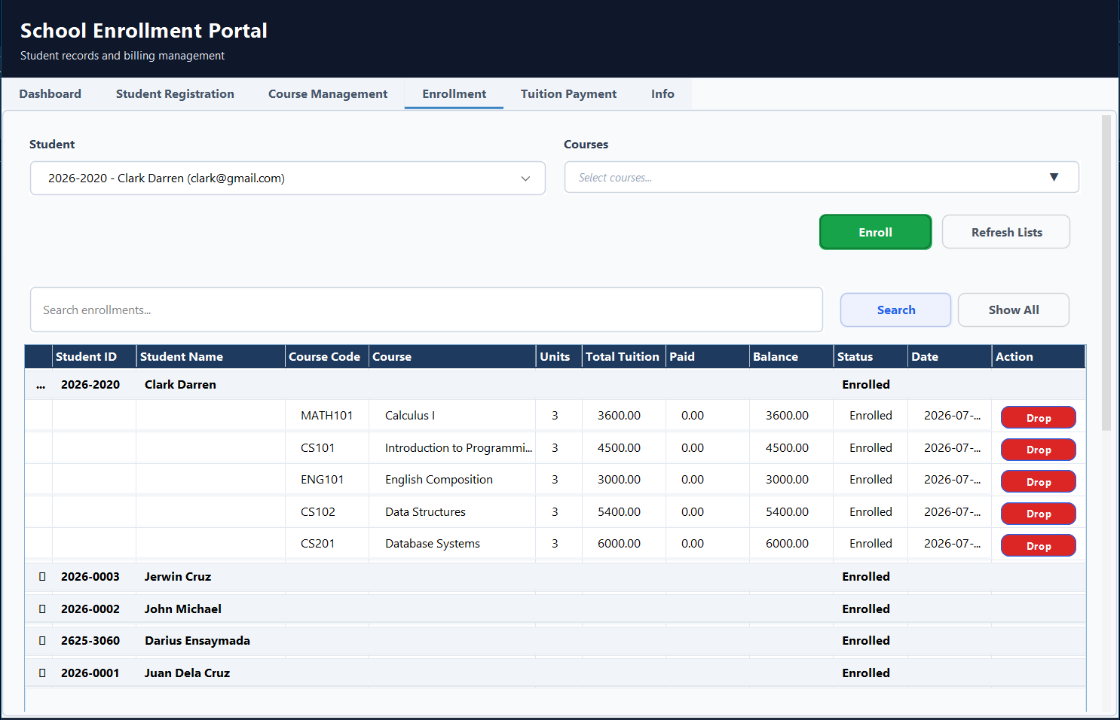
Figure 5.14. Enrollment

The Enrollment dashboard allows administrative staff to enroll students in selected courses, monitor records, track tuition balance, and status to efficiently monitor student enrollment.

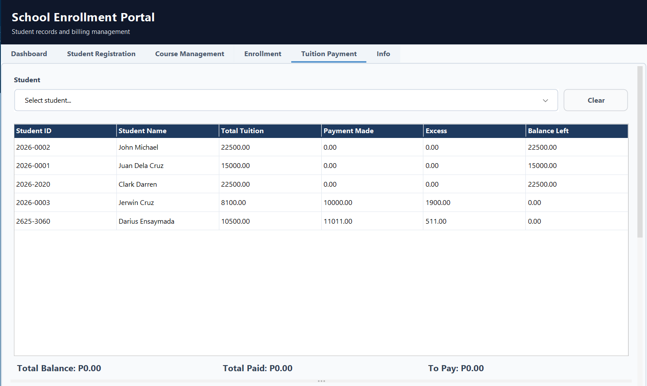
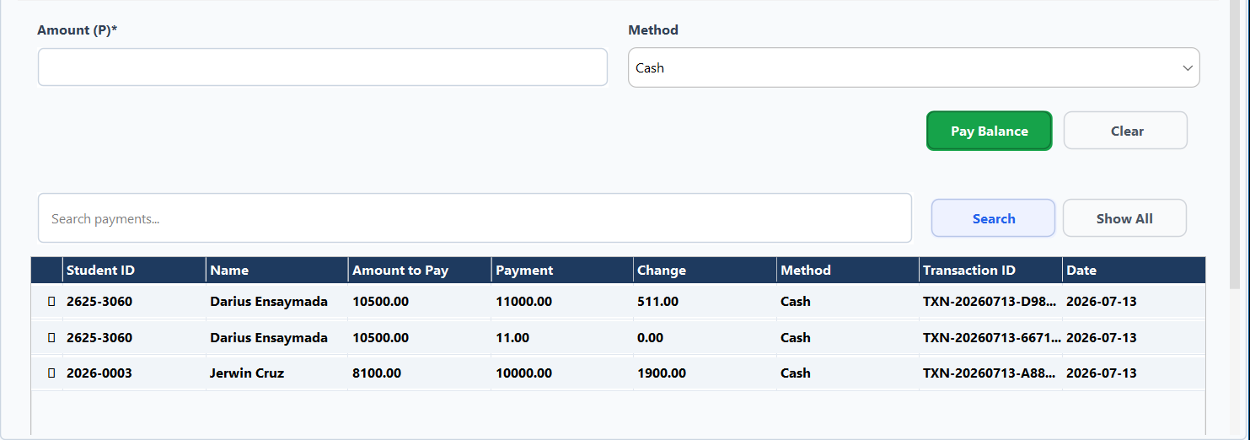
Figure 5.1.5. Tuition Payment

The Tuition Payment Dashboard enables administrators to monitor students' tuition balances, process payments, calculate remaining balances or excess payments, and maintain a complete payment history with transaction details for accurate and efficient financial management.

5.2 System Process
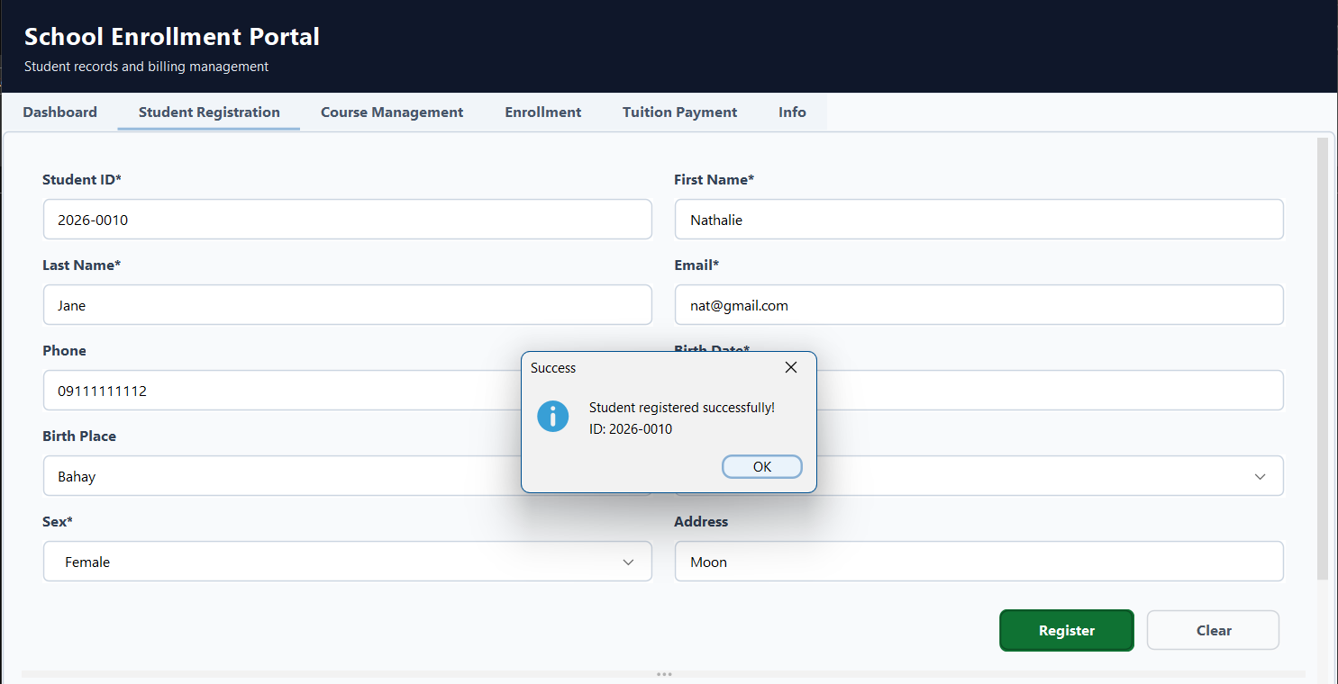
Figure 5.2.1. Student Registration

The system validates the entered student information, registers the student by saving the record to the database, generates a unique student ID, and displays a confirmation message indicating that the registration was completed successfully.

Figure 5.2.2. Enrollment

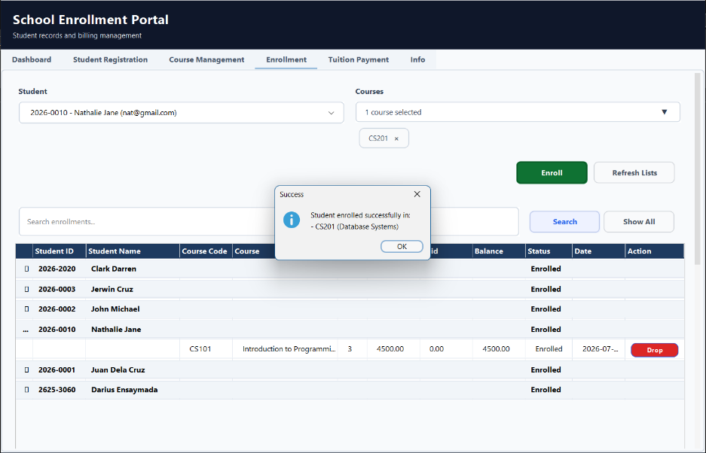

The system validates the entered student information, registers the student by saving the record to the database, generates a unique student ID, and displays a confirmation message indicating that the registration was completed successfully.

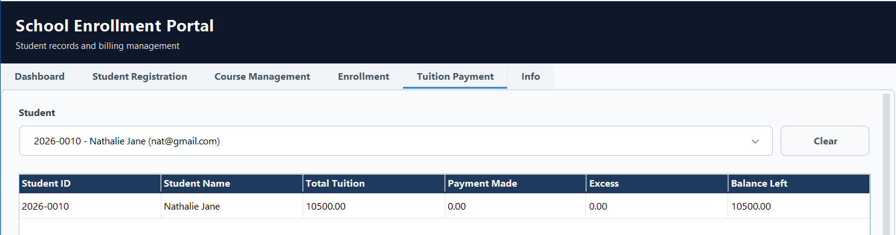

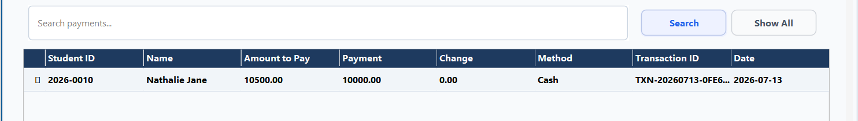
Figure 5.2.3. Tuition Payment

The system processes the student's payment, updates the total amount paid and remaining balance, records the transaction details, and displays the payment in the payment history.

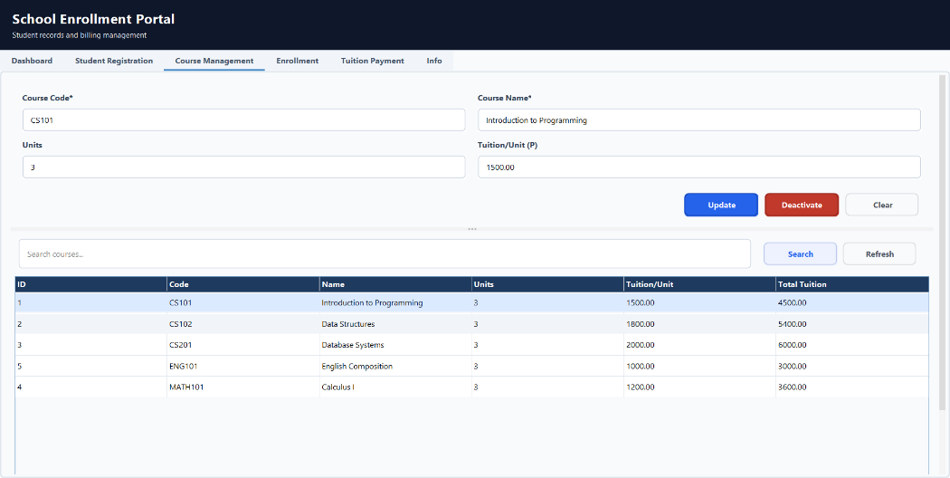
Figure 5.2.4. Course Management

The system can add new courses and update the selected course information, saves the changes to the database, or deactivates the course if selected, and then refreshes the course list to reflect the latest records.

6.0 Conclusion

The Java-based Online School Enrollment System developed in this study successfully addresses the administrative and data-management challenges commonly encountered in registrar office workflows, such as redundant data entry, disorganized records, and the risk of manual computation errors. Through its four core modules, Student Registration, Course Management, Enrollment and Tuition Payment, and the Dashboard, the system consolidates the essential functions of the enrollment process into a single, structured platform. Based on the study of Necula (2024), By combining Model-View-Controller (MVC) architecture with the Data Access Object (DAO) design pattern, JDBC, and a MySQL database, the system separates the presentation layer from business logic and data-handling logic, resulting in an application that is easier to maintain, troubleshoot, and extend as the institution's needs evolve.

Based on Anderson (2004), The automatic computation of tuition based on unit count and rate per unit, together with the audit logging built into the payment module, minimizes the likelihood of human error during critical financial transactions, consistent with findings that computerization of administrative tasks reduces errors and speeds up processing time compared to manual methods. According to Haleem et al., (2022), The iterative, staff-centered design process, which prioritized the primary input tasks of the registrar's office over secondary actions such as viewing and editing, also reflects the broader observation that digital tools succeed when they are shaped around how administrative staff actually work rather than treated as a simple digitized checklist of tasks.

Overall, the system met its general and specialized objectives of streamlining student registration, course management, enrollment, and tuition payment through a structured, database-driven application. Aspa et al., (2025) stated that comparable online enrollment systems implemented in other schools have likewise been found to minimize errors, reduce waiting times, and optimize administrative tasks once deployed. Which suggests that the approach taken in this study is aligned with practices already validated in similar academic settings. At the same time, the system's current scope leaves room for further enhancement, particularly in the areas of automated testing with actual end-users and the integration of features that were not yet implemented in this version, which are addressed in the recommendations that follow.

7.0 Recommendation

The researcher recommends the following about the system.
- Conduct formal end-user acceptance testing with actual registrar staff, instructors, and students, and evaluate the system using an established software quality model, such as ISO/IEC 25010, covering functionality, reliability, reliability, usability, efficiency, maintainability, and portability, to identify gaps not apparent during development (Aspa et al., 2025).
- Integrate an online or digital payment gateway into the Tuition Payment module so that trainees can settle fees remotely, addressing a limitation that similar enrollment systems without this feature have been found to face (Aspa et al., 2025).
- Involve registrar staff, trainers, and trainees as stakeholders in future revisions of the system, since interfaces designed around how administrative staff work have been shown to reduce errors and improve adoption more effectively than interfaces built around generic CRUD operations alone (Haleem et al., 2022).
- Set up routine, automated backup and recovery procedures for the MySQL database to safeguard student and financial records against accidental loss, since the risk of data loss was one of the original problems the system was designed to prevent.
- Provide structured orientation and reference documentation for registrar and administrative staff prior to full deployment, so that the transition from manual or semi-digital processes to the new system does not itself become a new source of error.
- Explore a mobile-responsive or companion mobile version of the system in future iterations, allowing students and staff to check enrollment status, schedules, and payment records outside of the registrar's office.
- Continue applying the MVC and DAO design principles when adding new modules or reports, such as certificate issuance or grade issuance, so that the separation of concerns achieved in this version is preserved as the system grows (Necula, 2024).

References

Anderson, R. (2004). Security engineering: A guide to building dependable distributed systems (2nd ed.). Wiley. https://books.google.com.ph/books?id=PkMtteGMT5EC
Aspa, S. M. C., Bonalos, C. M. B., Moredo, D. M. N., Peralta, N. O., & Ramos, R. A. (2025). Enhancing academic efficiency: A comprehensive online enrollment system for college students in Asbury College Incorporated. International Journal of Latest Technology in Engineering, Management & Applied Science, 14(1), 222-228. https://doi.org/10.51583/IJLTEMAS.2025.1401024
Haleem, A., Javaid, M., Qadri, M. A., & Suman, R. (2022). Understanding the role of digital technologies in education: A review. Sustainable Operations and Computers, 3, 275-285. https://doi.org/10.1016/j.susoc.2022.05.004
Necula, S. (2024). Exploring the Model-View-Controller (MVC) architecture: A broad analysis of market and technological applications. Preprints. https://doi.org/10.20944/preprints202404.1860.v1
Simon, M. K., & Goes, J. (2013). Scope, limitations, and delimitations. In *Dissertation and scholarly research: Recipes for success*. Seattle, WA: Dissertation Success LLC. Retrieved from https://ders.es/limitationscopedelimitation1.pdf

